|  |  |  |  |
| --- | --- | --- | --- |
| **Surname** | **Initials** | **Contact number** | **E-mail** |
| **Mphephu** | **TG** | **0728897876** | **mphephutshanduko@gmail.com** |
| **Mboxwana** | **L** | **0728450658** | **mboxwanalihle123@gmail.com** |
| **Ndlovu** | **Z** | **0724408944** | **zanomabena@gmail.com** |
| **Mokoena** | **GTS** | **0796964819** | **simonethenjiwe.st@gmail.com** |
| **Mokwena** | **N** | **0660776203** | [**nuttymokwena@gmail.com**](mailto:nuttymokwena@gmail.com) |

MONATE FOOD SYSTEM PROPOSAL

**Table of Content**

**Introduction ..................................................................... 2**

**Background .......................................................................2**

**Languages .........................................................................3**

**Deployment Diagram.........................................................4**

**Requirements ...................................................................5**

**Business Process ...............................................................6**

**Use Case Diagram .............................................................7**

**Planning............................................................................8**

**Gantt Chart .......................................................................9**

**INTRODUCTION**

Our system, Monate Food we are planning on developing a food ordering system that helps our clients to be able to order their meals online from our restaurant instead of coming to the restaurant all the time when they need food.

This system will also help on saving the world from the spread of covid-19. This system will also be including delivery for customers that are unable to come to the store. Our system will be user friendly and data free.

**BACKGROUND**

The reason behind the development of the Monate Food system is to make it easy for people to get food from wherever they are around at any time. There are several similar system that are currently existing like SHEIN which was developed by Chris XU in 2008 and MrD which was founded in 1992 in Cape Town, and got acquired by Takealot in 2014 which was found by Kim Reid.

**There are four languages included in our system:**

Visual studio code

We will be using visual studio as our IDE to edit, style our webpages and database system.

HTML

The reason why we using the Hyper-Text Mark Up language is that it is simple to implement and it loads webpages faster. It is also one of the best to collaborate with other languages and defines the content of web pages.

PHP

Hyper-Text Pre-processor will be used to create forms and dynamic content that interacts with the database.

CSS

The Cascading Style Sheet is to further enhance the interface in terms of background colour/image, text-decoration and margin alignment. It also specify the layout of web pages.

JavaScript

We will be using this scripting language to make our webpages because compared to its competitors, it is simple to learn and implement.

MySQL

Will be used to link the input information from the JavaScript to the database system and is regarded for being the most secure and reliable database management system. Which the connection will be made through our chosen IDE called visual studio code by clicking the server explorer in the menu view.

**DEPLOYEMENT DIAGRAM**

**REQUIREMENTS**

Functional requirements

* Allows the customers to login.
* Allows customers to place an order online.
* Allows a customer to do payment online.
* Indicates when the customer has paid for the food.
* Alert drivers or delivery man when the order is ready.
* Alert the customer when the food has arrived.

**Non-functional requirements**

**Usability**-our system will be as user friendly as possible. It will provide users with help manual and there will be also be a guide directly on the system. The system is very considerate, no matter your educational level, it does not even need any prior experience.

**Reliability**-our system can allow as many customers as possible to login as long they provide correct and proper account info, and will not allow multiple logins into an account of one client from different devices at the same time.

**Performance**-Our system will be capable of notifying the customers as soon their order is successful placed within a short period of time.

**Maintenance –** we will be able to recover customer’s login details and their order if anything wrong happens.

**Security –** our client’s personal and banking information won’t be compromised since the client’s information will never be shared with any third party organization.

**BUSINESS PROCESS**

Business Process Diagram

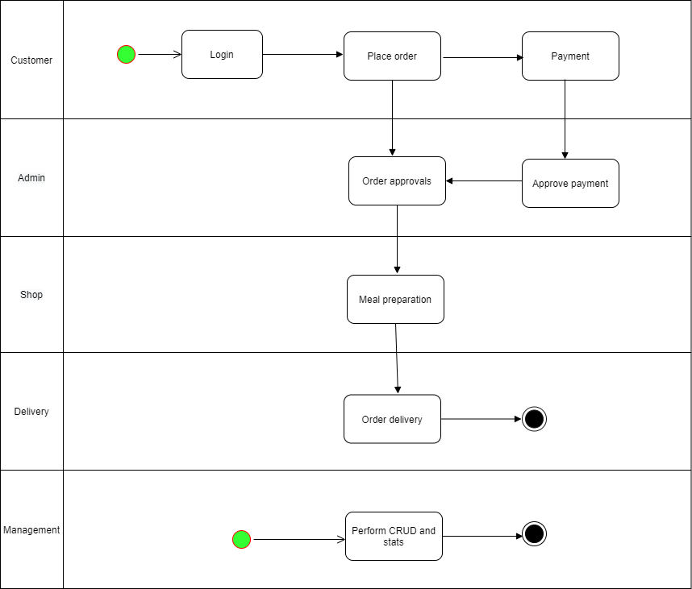

**USE CASE DIAGRAM**

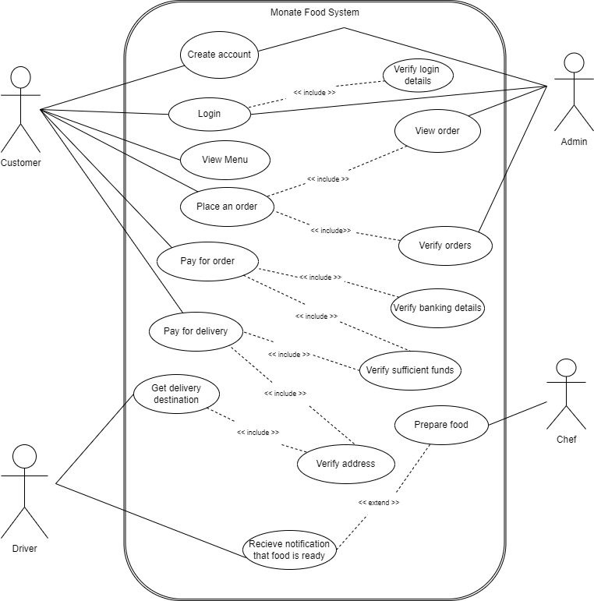

**PLANNING**

**Week one-Week two:**

* Brainstorming with the team
* Start working on the proposal
* Interview users and employees
* Draw the structure of the system
* Point out system requirements

**Week three-Week four**

* Identify stakeholders and gather funds
* Assemble resources
* Architectural analysis of the system
* Design database

**Week five-week six**

* Design programming details
* Begin coding

**Week seven**

* System testing
* Deploy solutions required
* System implementation

**GANTT CHART**

